**Project Name:** Magnetic Levitation.

# Objective:

The objective of the magnetic levitation project is to explore and demonstrate the principles of magnetic levitation through practical experimentation. By utilizing magnets and electromagnetic fields, the project aims to achieve stable levitation of an object. This technology has various potential applications such as transportation systems, frictionless bearings and even high-speed trains. Through this project we gained hands-on experience with electromagnetism even sensor technologies.

## Methodology:

There are several ways to execute the project, such as

1. By using the Hall sensor effect
2. By using an IR sensor.

Here we use IR sensor to execute the whole project.

## Component:

* + Bread board
  + IR LED
  + Photo diode
  + Resistor
  + IC LM 358
  + Bread Board power Supply
  + Jumper Wire
  + Source
  + Relay
  + Base

### IR LED

IR LED emits light, in the range of Infrared frequency. IR light is invisible to us as its wavelength (700nm – 1mm) is much higher than the visible light range. Everything which produce heat, emits infrared like for example our human body. Infrared have the same properties as visible light, like it can be focused, reflected and polarized like visible light. IR LED looks like a normal LED and also operates like a normal LED, it consumes 20mA current and 3vots power. IR LEDs have light emitting angle of approx. 20-60 degree and range of approx. few centimeters to several feet, it depends upon the type of IR transmitter and the manufacturer. Some transmitters have the range in kilometers.

### PhotoDiode

Photodiode is considered as Light dependent Resistor (LDR), means it has very High resistance in absence of light and become low when light falls on it. Photodiode is a semiconductor which has a P-N junction, **operated in Reverse Bias**, means it start conducting the current in reverse direction when Light falls on it, and the amount of current flow is proportional to the amount of Light. This property makes it useful for IR detection.



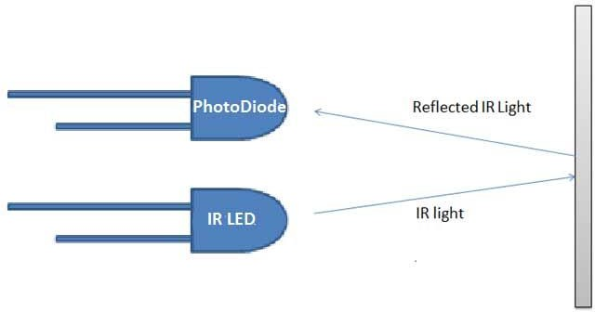

The placing of IR LED and Photodiode can be done in two ways: **Direct and Indirect**. We use in this project **Direct use of IR light**. In **Direct incidence**, IR LED and photodiode are kept in front of one another, so that IR radiation can directly falls on photodiode. If we place any object between them, then it stops the falling of IR light on photo diode .We use it like a switch.

### Electromagnet:

Creating a magnet using a coil involves the principles of electromagnetism, where an electric current passing through a wire coil generates a magnetic field. When the wire is wound into a coil, the magnetic fields from each loop combine to form a stronger overall field. Typically, insulated copper wire is used, wrapped tightly around a ferromagnetic core, such as an iron nail. This core enhances the magnetic field produced by the coil. Connecting the wire ends to a DC power source, like a battery, allows current to flow, generating a magnetic field and magnetizing the core. The strength of the electromagnet depends on factors like the number of wire turns, the current intensity, and the core material.

# Circuit Diagram:

# IR Module:

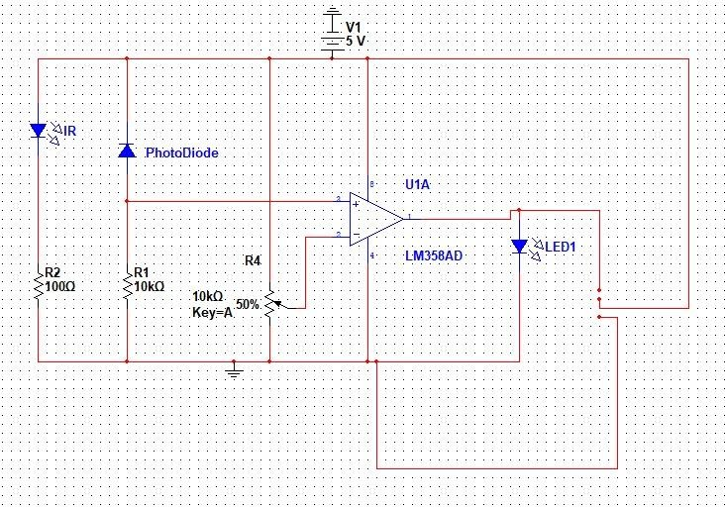

**Relay module:**

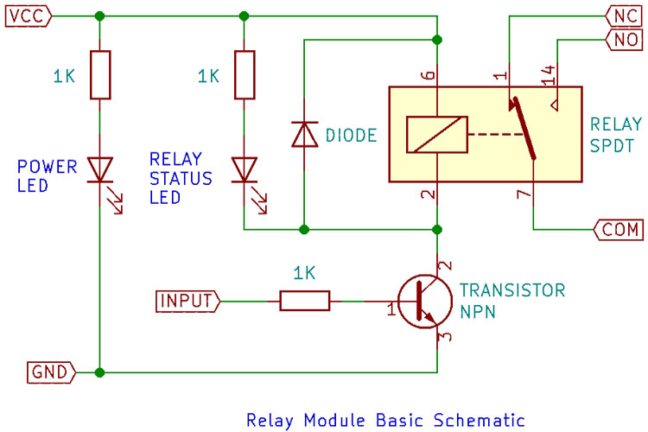

**Procedure:**

1. First we made electromagnet by hand.
2. Then we place the IR LED and Photodiode face-to-face (Directly). It took a lot of trouble to match the sensor with the magnet.
3. We use relay for switching.
4. When a IR sensor detect a object, it turns off the magnetism. As a result electromagnet stopped.
5. Because of gravity the object start to fall down.
6. Now photo-diode can pass the light, so that the electromagnet turns on again.
7. Then as usual the rule of electromagnet it attract the object again.
8. The Process will go on continuously. It happens more than 100 times in a second.
9. As result the object will float in air.

# Conclusion:

First, we connect our coil to our circuit, which was made with an OP-AMP LM 358 IC. But it wasn’t able to supply the necessary output voltage. So that we change our decision and connect with the IR module. But as mentioned, we made our coil on our own, so the coil isn’t uniform. That’s why the magnetic flux is also non-uniform. We need more fast switching, but relay is unable to switch that much fast. Because of this, our ultimate goal of levitation isn’t possible accurately. Now it’s working a little bit, but not as per our expectations.